Anatomy of Android Application

The android app project will contain different types of app modules, source code files, and resource files. To see the actual file structure of the project, select Project from the Project dropdown instead of Android.

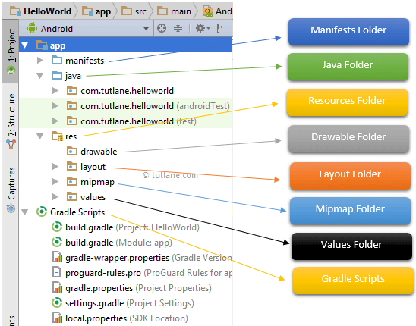

Java Folder
This contains the .java source files for your project. By default, it includes an MainActivity.java source file. Under this, you create all the activities which have .java extensions and all the code behind the application. MainActivity.java is the actual file which gets converted to a dalvik executable and runs your app. the class file MainActivity.java will create automatically under the package name “com.tutlane.helloworld” like as shown below.

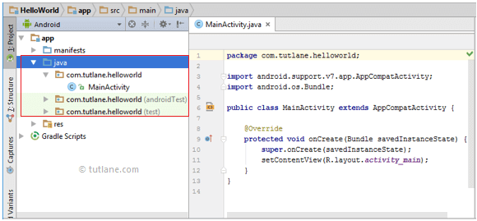

(1) Activity is a java class that creates and default window on the screen where we can place different components such as Button, EditText, TextView, Spinner etc. It is like the Frame of Java AWT.
It provides life cycle methods for activity such as onCreate, onStop, OnResume etc.
(2) The onCreate method is called when Activity class is first created.
(3) The setContentView(R.layout.activity_main) gives information about our layout resource. Here, our layout resources are defined in activity_main.xml file.

res (Resources) Folder
This folder contains all the resources like icons, images etc related to our application project It’s an important folder that will contain all non-code resources, such as bitmap images, UI strings, XML layouts like as shown below
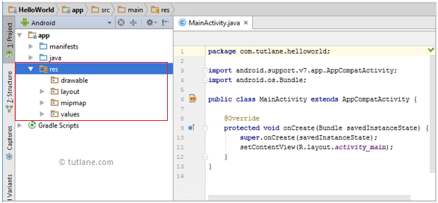

The res (Resources) will contain a different type of folders that are

Drawable Folder (res/drawable)
It will contain the different types of images as per the requirement of application. This folder contains xml, png, jpg and jpeg files. In this folder you can store images which are used in your app and other .xml files which are used for many purposes like creating button background, or shadow effect etc.

Layout Folder (res/layout)
This folder will contain all XML layout files which we used to define the user interface of our application. Following is the structure of the layout folder in the android application.

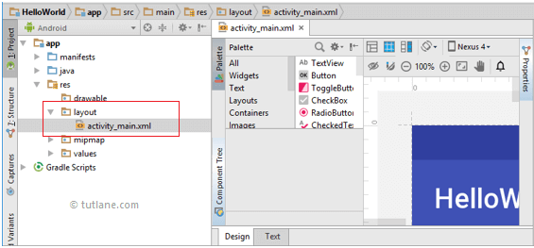

Mipmap Folder (res/mipmap)
This folder will contain app / launcher icons that are used to show on the home screen. It will contain different density type of icons such as hdpi, mdpi, xhdpi, xxhdpi, xxxhdpi, to use different icons based on the size of the device.

Following is the structure of the mipmap folder in the android application.

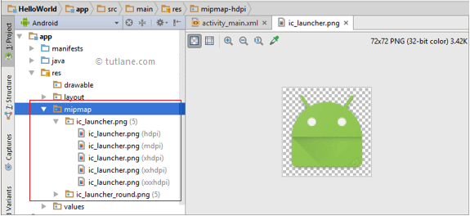

Values Folder (res/values)
This folder will contain various XML files, such as strings, colors, style definitions and a static array of strings or integers. Following is the structure of the values folder in android application.

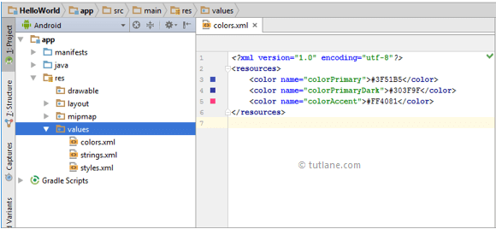

This folder contains default file like strings.xml, dimens.xml, colors.xml, styles.xml.
    - In strings.xml, you can specify all the string constants like title of screen or any other tag which are constantly used in your app.
    - In dimens.xml, you can create different .xml files to define dimensions as per resolution of screen and dimension of it and give any dimensions for padding, height, width, margin in this file.
    - In color.xml you can mention the list of colors using their hashcodes, used in your application. If this is not created by default, you can create this yourself.
    - In styles.xml you can define different readymade styles to use them directly anywhere in your Android App.

Manifests Folder
This folder will contain a manifest file (AndroidManifest.xml) for our android application. This manifest file will contain information about our application such as android version, access permissions, metadata, etc. of our application and its components. The manifest file will act as an intermediate between android OS and our application.

Following is the structure of the manifests folder in the android application.

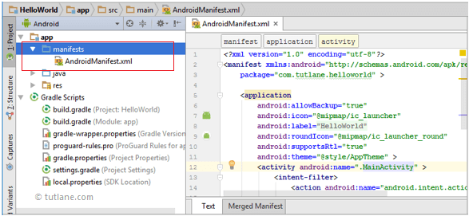

Gradle Scripts
In android, Gradle means automated build system and by using this we can define a build configuration that applies to all modules in our application. In Gradle build.gradle (Project), and build.gradle (Module) files are useful to build configurations that apply to all our app modules or specific to one app module.

Following is the structure of Gradle Scripts in the android application.

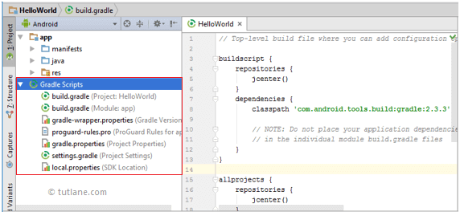

build Folder
This folder contain R.java file, which is an auto generated file. This file indexes all the resources of the android application project like layout xml, strings xml etc and it is auto generated.
In build folder, you will have application's debug and release apk files, created when you build your project.

libs folder
If you want to use any external library, all you have to do is copy-paste the .jar file into the libs folder and then you can directly use it in you .java code files.

gradle folder
In this folder there are files related to gradle which can be modified to alter the project building process. For example: If you wish to run all the available test cases before building the .apk file, you can do so by mentioning it in the gradle file.

